**Introduction**

Electroluminescence (EL) is a method that is widely used to identify inactive and/or defective cells in solar panels. This is done by running a current through the solar panel which results in the emission of light without heat due to the phenomenon known as electroluminescence. This light can then be captured through the use of an infrared camera. The image produced highlights the internals of a solar panel similar to how an x-ray is used to image a person’s bones.

To operate optimally, typical EL systems require specific conditions. These conditions include camera, temperature, and lighting requirements. The camera requirements include the type of sensors which are typically CDD or CMOS, resolution which are typically between 1 to 5 megapixels, and light sensitivity that includes dynamic range, exposure time, and wavelength which is typically 950nm to 1000nm. Next, the system requires an ambient temperature of between 20C to 25C. Lastly, the system requires a dark room for optimal capture of infrared images. To satisfy these requirements, typical EL systems are built using expensive cameras and have a large, dedicated room to meet the environmental requirements.

* Dismantling solar panels not required

**Scope**

The EL system to be designed will be a portable system that can image only one solar panel at a time. As the intended design is a portable system, the external noise from the ambient temperature and light cannot be removed. Therefore, the system will have to account for these factors to produce an accurate estimation. The method to account for the external noise will involve capturing infrared images when current is run through the panel (bright state) and when no current is sent to the panel (dark state). The bright and dark images will then be minus from each other to remove the noise. To be able to achieve this, the system will need to be able to run a specified current that meets the rating of different types of solar panels. As the camera will need to be captured at the right moment where current is running through the solar panel, it needs to be timed correctly. This will be managed using an algorithm on a computer. Furthermore, the computer can be used for the processing of the captured images. A stretch goal of this project involves designing and implementing a user interface that allows the user to easily define the input parameters and outputs the resulting EL image.

**Stakeholder Analysis**

|  |  |  |
| --- | --- | --- |
| Stakeholder | Description | Interaction Plan |
| Client | Project Client Marco and Hieu who provide funding and advice | Weekly meetings and remaining in frequent contact through the project coordinator |
| Design Team | The engineering team consisting of the 6 members that will work on this project | Weekly meetings and remaining in frequent contact through the use of a team chat channel |
| ANU | The university where this project is being undertaken who might be interested in the end result of this project | No interaction planned unless ANU takes interest in the project towards the end of project. Then the client and project team will discuss with the ANU |
| ANU Solarcar | The initial people who approached the client regarding the use of a portable EL system | Client is in contact with ANU Solarcar. Opportunities may arise to perform real-world test on ANU Solarcar’s solar panels and will be organised by the client. |
| ANU PV Group | The research group the client operates in who might be interested in the end result of this project | No interaction planned, all handled via the client. |
| End User | The users of this system who desire to use an EL system on their solar panels | Only end user that may be interacted with is the ANU Solarcar, organised through the client. |
| Solar panel testing companies (i.e. PVLAB) | The companies that currently perform EL imaging who might be interested in expanding their market to portable EL imaging | No interaction planned due to early stage of project. |
| Competitors | Other companies who are currently producing or developing portable EL systems | No interaction planned. Research on competitor performed to undertake requirement benchmarking |
| Regulation bodies | The regulators who ensure that the product is safe for the end users | No interaction planned. Standards will be identified online and applied in the project |
| Solar panel manufacturers | The companies who make solar panels and might innovate the technology | No interaction planned. Team plans for frequent check up on manufacturers to identify any potential innovation in solar panels that may affect the project |
| Component Suppliers and Manufacturers | The companies where the components are sourced from | Items purchased from suppliers and manufacturers through the client. No further interaction planned. |

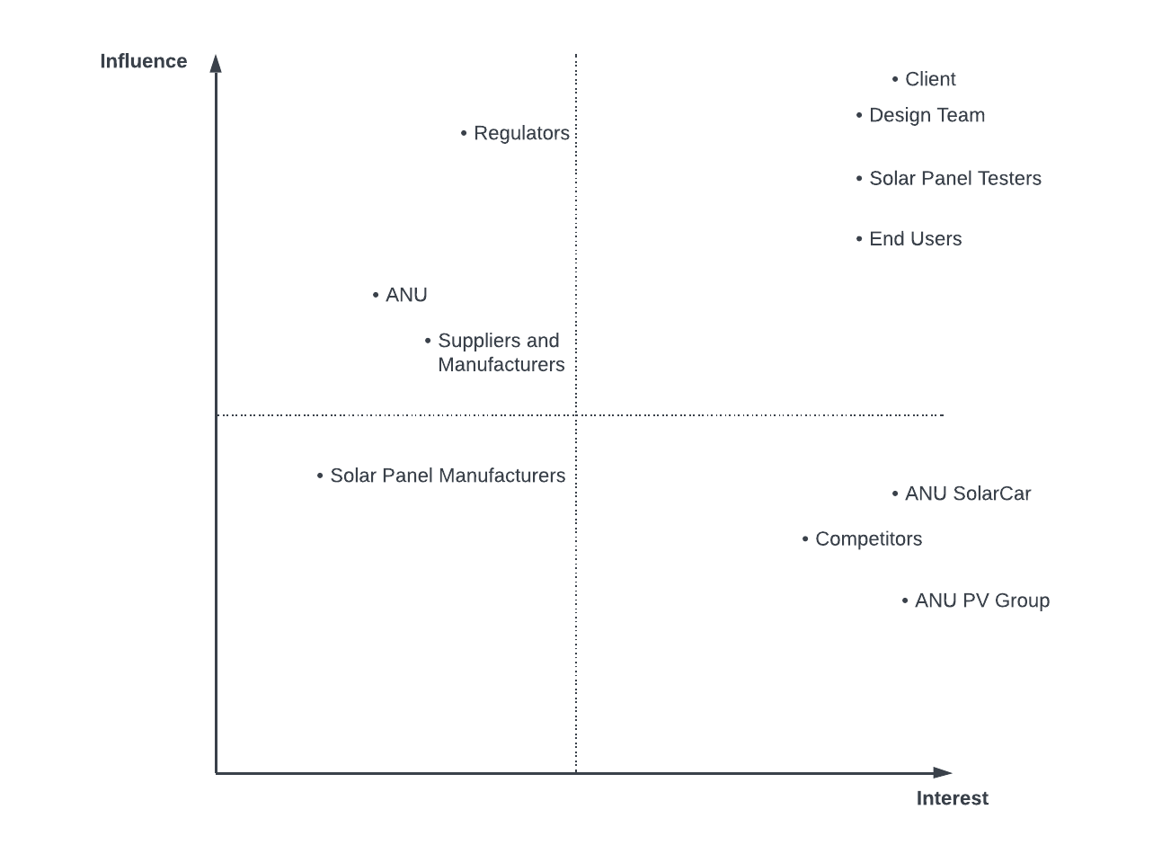

**Needs Analysis**

|  |  |  |  |  |  |
| --- | --- | --- | --- | --- | --- |
| ID | Need | Importance | Source | Validation | Comments |
| N1 | Performs electroluminescence measurement | Essential | Client | Yes/no | Simple can it perform EL question? |
| N2 | Portability | Essential | Client | Weight, number of components, ease of setup | Compare to non-portable system |
| N3 | Easy setup | Highly Desirable | ANU SolarCar, Customers | Time taken, number of steps required to setup/initialise system | Consider time system requires to initialise, consider how many inputs users must manually enter, consider how much manual labour user must perform to setup |
| N4 | Fast measurement | Highly desirable | Client, ANU SolarCar, Customers | Time taken to produce output after initialisation of system | None |
| N5 | High quality output EL images | Essential/  Highly desirable | Client, ANU SolarCar, Customers, Solar Panel Testers | Image Quality, pixel per inch | Measure pixel per inch? 160PPI for screen and 300 PPI for print, need to research different measurement of image quality |
| N6 | Durable system | Essential | Client/ Customer | Waterproof, dustproof, scratchproof | Lifespan |
| N7 | Ease of maintenance | Highly desirable | Customer | How often? Local availabilities of parts, lead times | None |
| N8 | Easy to use | Highly desirable | Customer | Number of inputs available to user | None |
| N9 | Reasonable cost | Highly desirable | Customer/ Solar Panel Testers | Purchase cost, repair cost, parts cost | None |
| N10 | Safety | Essential | Regulators | Satisfaction of regulations and standards | None |
| N11 | Operates in any environmental condition | Essential | Client/ design team | Compare result to expected result in ideal condition | None |

**Requirements Analysis**

|  |  |
| --- | --- |
| ID | Requirement Statement |
| R1.0 | The EL system must be able to perform electroluminescence imaging on at least 1 solar panel at a time. |
| R2.0 | The EL system must not weigh more than 18.5kg. |
| R3.0 | The EL system should be able to image solar panels for at least 8 hours per day. |
| R4.0 | The EL system should be operable within 10 minutes after turning on. |
| R5.0 | The EL system must have a lifespan of at least 1 year. |
| R6.0 | The EL system must satisfy the waterproof rating of IP65. |
| R7.0 | The EL system must be able to withstand wind speeds of up to Rating 6 on the Beaufort Wind Force Scale. |
| R8.0 | The EL system must satisfy the scratchproof rating of 5 on the Mohs Scale of Hardness. |
| R9.0 | The EL system should be able to output electroluminescence images of solar panels within 20 minutes after being operable depending on environmental conditions. |
| R10.0 | The EL system must be able to output electroluminescence images with at least 160 PPI (pixels per inch). |
| R11.0 | The EL system must be able to output electroluminescence images with at least a resolution of 320 x 256 pixels. |
| R12.0 | The EL system should only allow users to manually configure a maximum of 5 inputs. |
| R13.0 | The EL system should utilise parts that can be obtained within 2 weeks. |
| R14.0 | The EL system should not cost more than $1,500 AUD. |
| R15.0 | The EL system must satisfy AS 5139:2019 Electrical installation standards of safety. |
| R16.0 | The EL system should utilise a pulse pattern to send current with consistent intervals. |
| R17.0 | The EL system must be able to output electroluminescence images under any lightning condition up to 6,000 lumens. |
| R18.0 | The EL system must be able to be stabilised and used in any terrain up to a slope of 35 $°$ |

Benchmarking systems

* <https://www.mbj-solutions.com/en/products/mobile-equipment/mbj-mobile-el>
* <https://brightspotautomation.com/products/el-camera-travel-system/>
* <https://www.hyperioninstruments.com/assets/docs/Helios_Datasheet_v1.3.pdf>

**Requirements Rationale Table**

|  |  |  |  |  |  |
| --- | --- | --- | --- | --- | --- |
| ID | Requirement | Essentiality | Source | Validation methods | Rationale |
| R1.0 | Able to perform electroluminescence imaging | Essential | Client | Test | This is the main function of the desired system. |
| R2.0 | Weight of below 18.5kg | Essential | Client | Weighing system | System should be carriable by an average adult. |
| R3.0 | Operation time of at least 8 hours | Highly desirable | Client/End User | Test | System should operate for one working day. |
| R4.0 | Initialisation time of 10 minutes | Highly desirable | ANU Solarcar/ End User | Test | The system should be operable quickly after being turned on. |
| R5.0 | Lifespan of at least 1 year | Essential | Client/End User | Based on warranty of components used | Typical warranty ranges from 1-3 years but benchmark system provides 1 year of warranty |
| R6.0 | Waterproof rating of IP65 | Essential | Client/End User | Satisfaction of rating requirements | IP65 makes the system dust resistant and water resistant to light jet streams. |
| R7.0 | Wind speed rating of 6 on Beaufort Scale | Essential | Client/End User | Satisfaction of rating requirements | Rating 6 allows system to be resistant to strong breezes. |
| R8.0 | Scratchproof rating of 5 on Mohs Scale | Essential | Client/End User | Satisfaction of rating requirements | Rating 5 allows the system to be as scratch resistant as a modern mobile phone. |
| R9.0 | Able to produce result within 20 minutes of operation | Highly desirable | Client/ANU Solarcar/ End User | Test | Imaging should be performed quickly given the environmental conditions. |
| R10.0 | Image quality of at least 160PPI | Essential | Client/ANU Solarcar/ End User/ Solar Panel Testers | Test | 160PPI is the standard image quality for images viewed on a screen. |
| R11.0 | Image resolution of at least 320x256 pixels | Essential | Client/ANU Solarcar/ End User/ Solar Panel Testers | Test | Based on benchmark system where the standard image resolution is 320x256 pixels. |
| R12.0 | Maximum user input of 5 | Highly desirable | End User | Counting inputs | System should be intuitive to use and limit amount of input users must set manually. |
| R13.0 | Lead time of max 2 weeks | Highly desirable | End User | Based on standard delivery times of components | Core value of this project is accessibility and should utilise local, easy to source, components. |
| R14.0 | Maximum cost of $1,500 | Highly desirable | End User/ Solar Panel Tester | Summation of total component cost | Core value of this project is accessibility and should cost-effective components as current systems utilise expensive cameras upwards of $100,000. |
| R15.0 | Safety standard AS 5139:2019 | Essential | Regulators | Satisfaction of standard requirements | The standard of interest deals with the implementation of electrical device that utilises batteries. |
| R16.0 | Current is sent in a pulse pattern | Highly desirable | Client/ design team | Test | This is the core of the method being used to obtain accurate EL images in any lighting condition. |
| R17.0 | Able to perform electroluminescence up to 6000 lumen light | Essential | Client/ design team | Test | Ensures that system is able to operate under high light conditions as 6000 lumen is a standard bright day outside |
| R18.0 | Able to be used in terrain up to 35 $°$ | Essential | Client/ design team | Test | Ensures that system is able to operate anywhere up to the steepest rooftops. |

**Functional analysis**

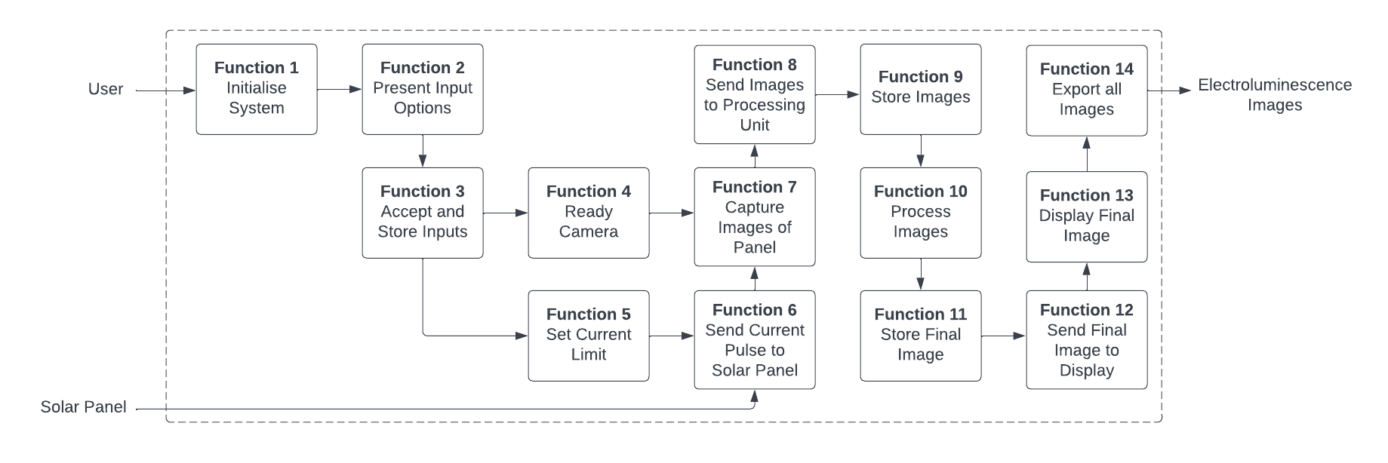

**Functional breakdown**

|  |  |  |
| --- | --- | --- |
| ID | Name | Description |
| 1.0 | Initialise System | The EL systems starts and prepares for imaging functionality. |
| 2.0 | Present Input Options | The EL system presents all input options to the user relevant to begin imaging. |
| 3.0 | Accept and Store Inputs | The EL system receives and stores user input. |
| 4.0 | Ready Camera | The EL system prepares the camera for operation based on user inputs. |
| 5.0 | Set Current Limit | The EL system prepares the current source for operation based on user inputs. |
| 6.0 | Send Current Pulse to Solar Panel | The EL system sends current to the solar panel in a pulse pattern based on the user input. |
| 7.0 | Capture Images of Panel | The EL system captures images of the solar panel. |
| 8.0 | Send Images to Processing Unit | The EL system sends the captured images to the processing unit. |
| 9.0 | Store Images | The EL system stores the captured images on the processing unit |
| 10.0 | Process Images | The EL system processes the captured images using computer vision algorithms to produce the final image. |
| 11.0 | Store Final Image | The EL system stores the final image on the processing unit |
| 12.0 | Send Final Image to Display | The EL system sends the final image to the display |
| 13.0 | Display Image | The EL system outputs the final image to the user on the display. |
| 14.0 | Export all Images | The EL system is able to export both the raw images and the final processed image from the system. |

**Causal Path**

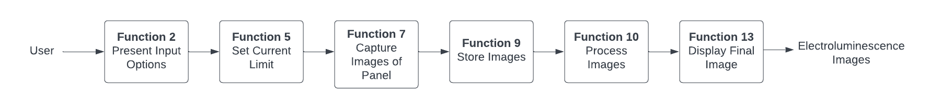

**Concept Generation**

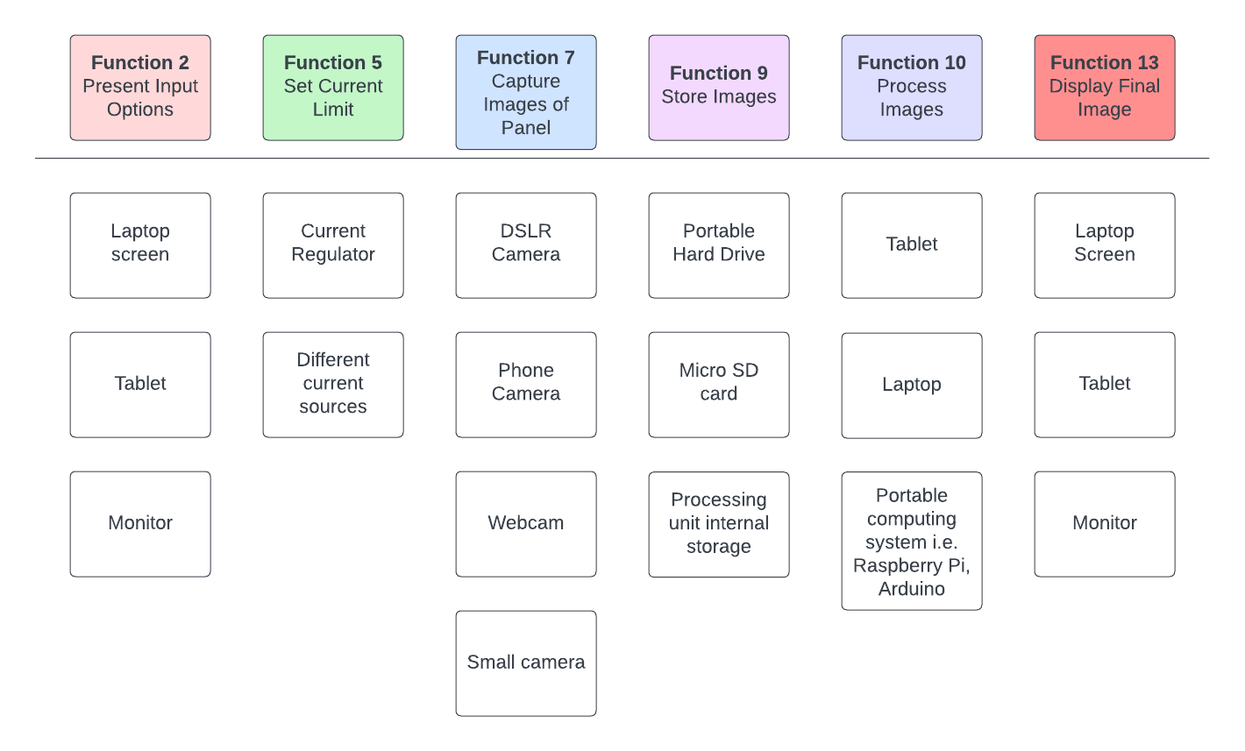

**Concept**

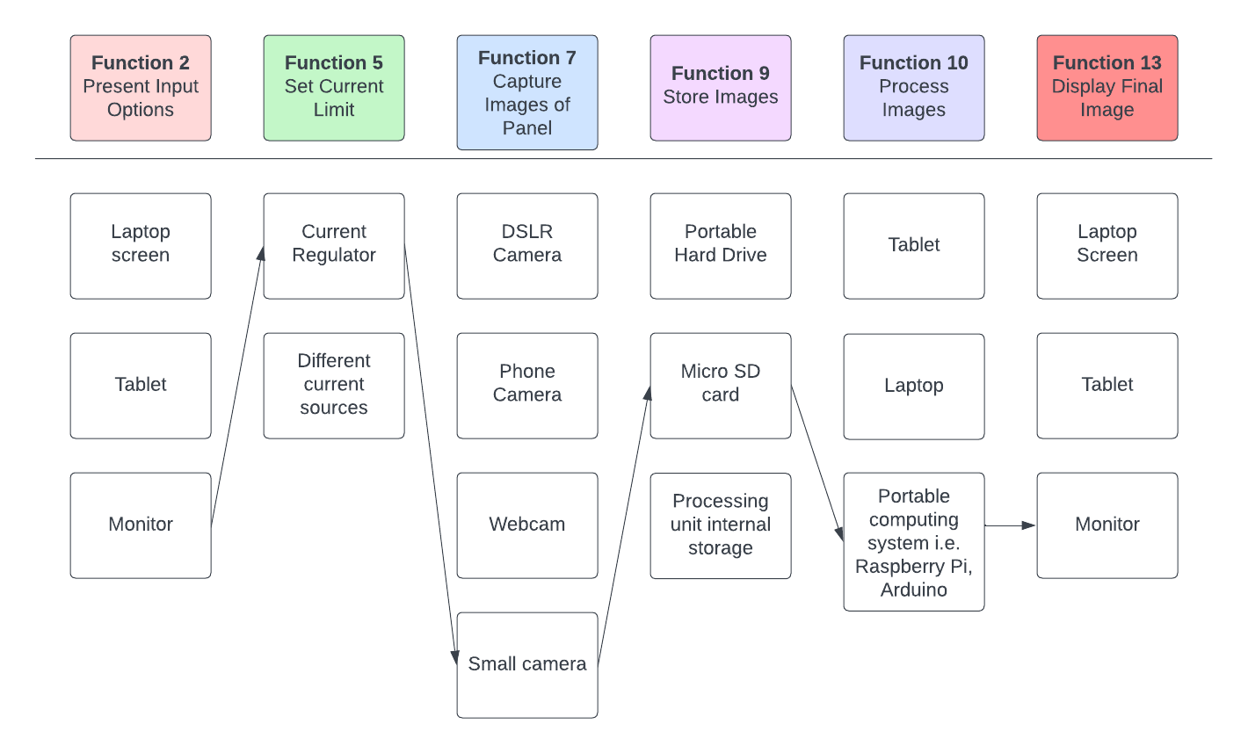

**System Architecture**

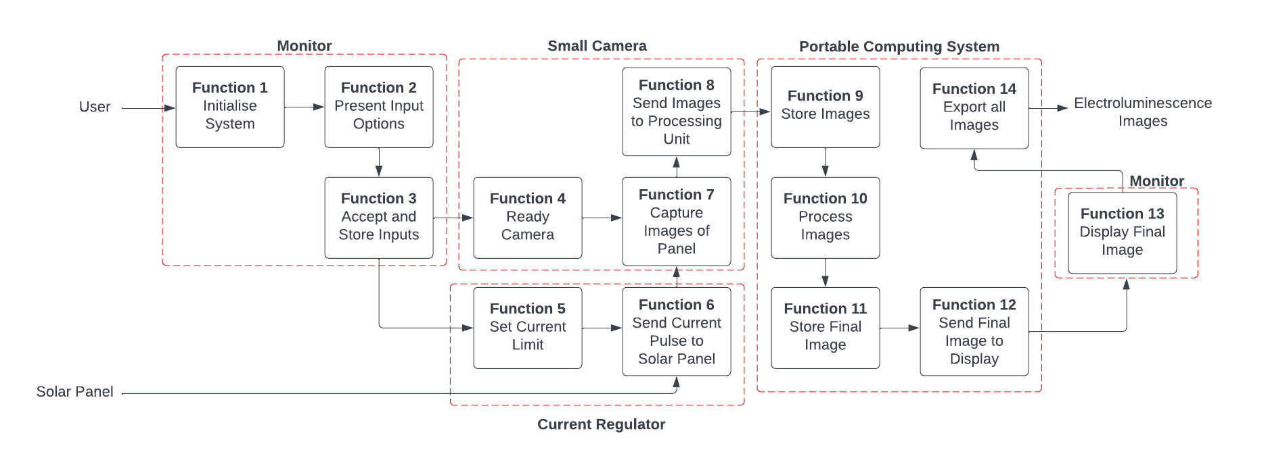

**Design Criteria**

|  |  |  |  |  |  |
| --- | --- | --- | --- | --- | --- |
| ID | Criteria | Units | Min | Max | Target |
| DC1 | Measurable number of solar panels per time | Total number | 1 | - | 1 |
| DC2 | Weight | Kg | 0 | 18.5 | 10 |
| DC3 | Daily Operable Time | Hours per day | 8 | - | 8 |
| DC4 | Initialisation Time | Minutes | 10 | 15 | 10 |
| DC5 | Lifespan | Years | 1 | - | 1 |
| DC6 | Waterproof rating | IP rating | 65 | 69 | 65 |
| DC7 | Windproof rating | Beaufort wind force scale | 6 | 10 | 6 |
| DC8 | Scratchproof rating | Mohs scale of hardness | 5 | 10 | 5 |
| DC9 | Measurement Time | Minutes | 20 | 30 | 20 |
| DC10 | Pixels Per Inch | PPI | 160 | 300 | 160 |
| DC11 | Number of User Inputs | Total Number | 5 | 8 | 5 |
| DC12 | Lead time for parts | days | 14 | 21 | 14 |
| DC13 | Cost | $AUD | 1500 | 1800 | 1500 |
| DC14 | Maximum operable lighting conditions | Lumens | 6000 | 8000 | 6000 |
| DC15 | Maximum operable terrain conditions | Slope degree | 35 | 45 | 35 |

**Technical Performance Metrics**

|  |  |  |  |  |  |  |
| --- | --- | --- | --- | --- | --- | --- |
| TPM | Dol* | Metric | Target | | Benchmark | Comments |
| Min | Max |
| Measurable number of panels per time | + | Total number | 1 | - | 1 | At least one solar panel needs to be measured, more is simply a benefit. |
| Weight | - | Kg | 0 | 18.5 | 18.5 | Needs to be light enough to be portable system |
| Daily Operable Time | + | Hours per day | 8 | - | 8 | Able to meet usage during business hours |
| Initialisation Time | - | Minutes | 10 | 15 | NA | Time required for system to become operable |
| Lifespan | + | Years | 1 | - | 1 | Warranty of system |
| Waterproof | - | IP rating | 65 | 69 | 66 | IP rating |
| Windproof | - | Beaufort Wind Force Scale | 6 | 10 | 6 | Beaufort Wind Force Scale |
| Scratchproof | - | Mohs Scale | 5 | 10 | 5 | Should match scratchproof of smartphone screens |
| Measurement Time | - | Minutes | 20 | 30 | 10 seconds per image (17 minutes for 100 images) | Time taken to complete one EL measurement. Accounts for 100 images and wait time in between each picture |
| Pixels Per Inch | + | PPI | 160 | 300 | NA | The higher PPI, the higher clarify of image |
| Number of user input | - | Total Number | 5 | 8 | NA | System should be more intuitive to use with fewer user inputs |
| Lead time for parts | - | Days | 3 | 14 | 5 | Amazon delivery is always 3-5 days within Australia |
| Cost | - | AU dollars | 1500 | 1800 | Couldn’t get quote | Cost of parts to assemble system |
| Maximum operable lighting conditions | + | Lumens | 6000 | 8000 | < 400 | Should be able to operate outdoors on a bright day. Benchmark requires use of a dark room/night time |
| Maximum operable terrain conditions | + | Slope degree | 35 | 45 | 30-40 | Should be able to operate on a slanted roof |

*Direction of Interest: + means we want to maximise, - means we want to minimise

